Content of contents
Supplemental figures
- Supplemental Figure 1 Flowchart for identification of patients undergoing bariatric surgery and matched patients
- Supplemental figure 2 Pyramid of propensity score distribution among bariatric surgery and matched control group
- Supplemental Figure 3 Mean cost of healthcare services for patients in bariatric surgery and control groups in the index year and subsequent four years

Supplemental Tables
- Supplemental Table 1 ICPC-2 and ICD-9-CM diagnosis/procedure codes list
- Supplemental Table 2 Unit cost of healthcare services and bariatric surgery
- Supplemental Table 3 Baseline characteristics of patients in the bariatric surgery and matched control group
- Supplemental Table 4 Mean dispensing days and costs of use of glucose-lowering medications
- Supplemental Table 5 Causes of death for surgical and control patients over five years
- Supplemental Table 6 Impact of patient covariates on annual direct medical costs (generalized linear model with log link of gamma distribution)
- Supplemental Table 7 Re-operation rates of patients in the surgery group in each year
- Supplemental Table 8 Direct medical costs incurred by surgical and non-surgical patients in the year before the index year

Supplemental Figure 1 Flowchart for identification of patients undergoing bariatric surgery and matched patients

668 patients were identified by relevant ICD-9-CM procedure codes.
64 patients were excluded due to BMI < 27.5 kg/m² on the index date
422 obese T2DM patients
288,017 patients without bariatric surgery were identified
245,187 non-obese patients were excluded
42,307 obese T2DM patients
1:5 propensity scores matching
401 obese patients
1,894 obese patients
Bariatric Surgery Group
Control Group
21 patients excluded
40,413 patients excluded
55 patients were excluded due to type 1 diabetes or gestational diabetes
523 patients were excluded due to type 1 diabetes or gestational diabetes
Cohort entry year | Bariatric Surgery Group | Matched Control Group
2006-2009 | 16 | 70
2010-2012 | 92 | 421
2013-2015 | 120 | 570
2016-2017 | 173 | 833

288,685 patients in record
76 patients underwent non-bariatric procedural operation were excluded
4 patients were excluded due to index date in the year of 2018
47 patients were excluded due to missing BMI

Supplemental figure 2 Pyramid of propensity score distribution among bariatric surgery and matched control group

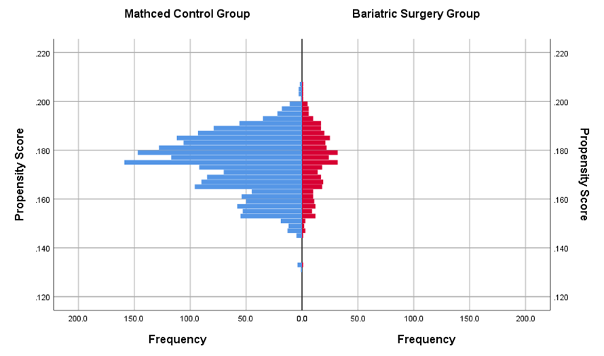

Supplemental Figure 3 Mean cost of healthcare services for patients in bariatric surgery and control groups in the index year and subsequent four years
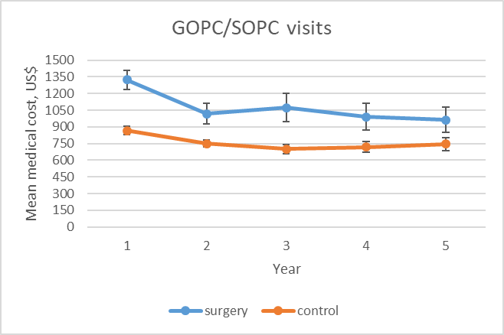  a | 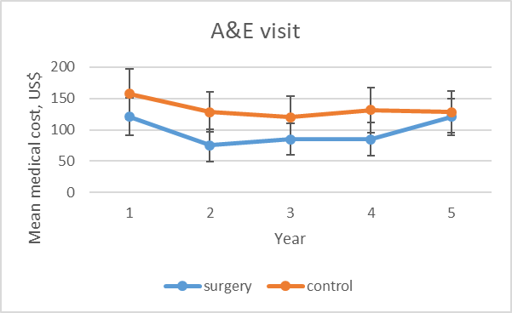  b
  Year | 1 | 2 | 3 | 4 | 5
  P value | <0.001* | <0.001* | <0.001* | <0.001* | 0.004*
  Year | 1 | 2 | 3 | 4 | 5
  P value | 0.088 | <0.001* | 0.085 | 0.116 | 0.783
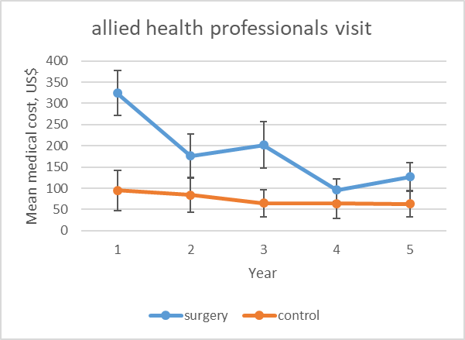  c | 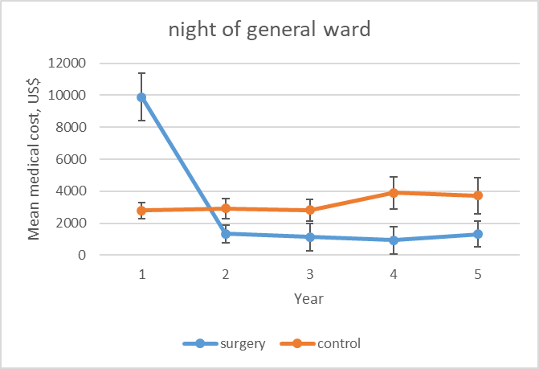  d
  Year | 1 | 2 | 3 | 4 | 5
  P value | <0.001* | 0.001* | <0.001* | 0.225 | 0.022*
  Year | 1 | 2 | 3 | 4 | 5
  P value | <0.001* | 0.040* | 0.060 | 0.022* | 0.088
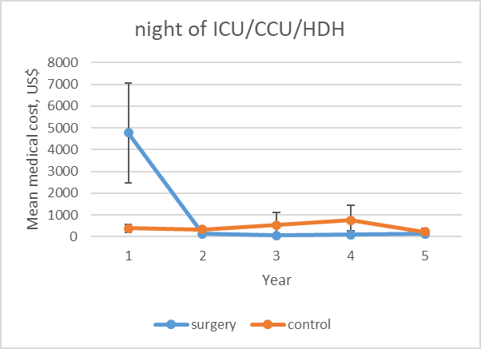  e | 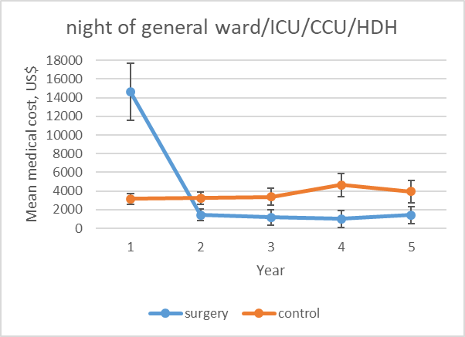  f
  Year | 1 | 2 | 3 | 4 | 5
  P value | <0.001* | 0.256 | 0.499 | 0.460 | 0.607
  Year | 1 | 2 | 3 | 4 | 5
  P value | <0.001* | 0.034* | 0.068 | 0.026* | 0.085
Notes: GOPC = general outpatient clinic; SOPC = specialist outpatient clinic; A&E = accident & emergency department; ICU = intensive care unit; CCU = cardiac care unit; HDU = high dependency unit

Supplemental Table 1 ICPC-2 and ICD-9-CM diagnosis/procedure codes list

Diseases | ICPC-2 Code | ICD-9-CM Code
Diabetes mellitus | T89, T90, W85 | 250.x
Type 1 diabetes mellitus | T89 | 250.01, 250.03, 250.11, 250.13, 250.21, 250.23, 250.31, 250.33, 250.41, 250.43, 250.51, 250.53, 250.61, 250.63, 250.71, 250.73, 250.81, 250.83, 250.91, 250.93
Type 2 diabetes mellitus | T90 | 250.00, 250.02, 250.10, 250.12, 250.20, 250.22, 250.30, 250.32, 250.40, 250.42, 250.50, 250.52, 250.60, 250.62, 250.70, 250.72, 250.80, 250.82, 250.90, 250.92
Hypertension | K86, K87 | 401.x
Mental health problems | P74-P77 | 296-311
Hyperlipidemia | T93 | 272.0-272.4
Obstructive sleep apnea | P06 | 327.20, 327.23, 780.51, 780.53, 780.57, 786.09
Gallbladder disease | U13 | 574-575.9
Musculoskeletal and chronic orthopedic disorders | L72-L81, L88-L90, L95-L96 | 710-739.99
Acute myocardial infarction | K75 | 410.x
Other ischemic heart disease | K74, K76 | 411-414.9
Congestive heart failure | K77 | 428.0-428.9
Stroke | K89, K90, K91 | 430-438.9
Peripheral vascular disease | K92 | 440.2*, 997.2, 997.6*
Severe hypoglycemia |  | 251-251.2, 270.3, 962.3
Chronic lung disease | R79, R95 | 490-496
Chronic renal disease |  | 585-586

Procedures | ICD-9-CM Procedure Code
Laparoscopic sleeve gastrectomy | 43.89
Laparoscopic gastric bypass | 44.39
Laparoscopic gastric banding | 44.99
Laparoscopic sleeve gastrectomy with duodenojejunal bypass | 43.89 and 45.91 on a same date
Laparoscopic plication of greater curve of stomach | 44.69
Duodeno-jejunostomy | 45.91

Supplemental Table 2 Unit cost of healthcare services and bariatric surgery
Items | Cost (HK$) | Cost (US$)§
Healthcare services†
Clinic visit
General outpatient clinic | 445 per visit | 57 per visit
Specialist outpatient clinic | 1,190 per visit | 153 per visit
Accident and emergency | 1,230 per visit | 158 per visit
Allied health professionals
Clinical Psychologist | 550 per visit | 71 per visit
Dietitian | 550 per visit | 71 per visit
Occupational Therapist | 550 per visit | 71 per visit
Physiotherapist | 550 per visit | 71 per visit
Smoking counselling and cessation centre | 550 per visit | 71 per visit
Hospitalization
General ward | 5,100 per day | 654 per day
Intensive care unit | 24,400 per day | 3,128 per day
Cardiac care unit | 24,400 per day | 3,128 per day
High dependency unit | 13,650 per day | 1,750 per day
Bariatric surgery and revision surgery‡
Laparoscopic sleeve gastrectomy | 114,585 | 14,690
Laparoscopic adjustable gastric banding | 105,410 | 13,514
Laparoscopic gastric bypass | 119,585 | 15,331
Laparoscopic sleeve gastrectomy with duodenojejunal bypass | 162,910 | 20,886
Laparoscopic plication of greater curve of stomach | 67,010 | 8,591
Duodeno-jejunostromy | 67,735 | 8,684
Note:
† Data source: 2017 Hong Kong SAR Government Gazette and Hospital Authority Ordinance (chapter 113): Public charges – non-eligible persons.
‡ Data source: 2017 Hong Kong SAR Government Gazette and Hospital Authority Ordinance (chapter 113): Private charges (mid-point value); and personal communication with bariatric surgeons
§ At a fixed exchange rate of 1 US= 7.80HK.

 | Cost components (HK$) |  |  | Total cost (HK$) | Total cost (US$)¶
 | OGD†‡ | Surgery‡ | Consumables§ | Total cost (HK$) | Total cost (US$)¶
Bariatric surgery
Laparoscopic sleeve gastrectomy | 9,410 | 80,175 | 25,000 | 114,585 | 14,690
Laparoscopic gastric banding | 9,410 | 66,000 | 30,000 | 105,410 | 13,514
Laparoscopic gastric bypass | 9,410 | 80,175 | 30,000 | 119,585 | 15,331
Laparoscopic sleeve gastrectomy with  duodenojejunal bypass | 9,410 | 123,500 | 30,000 | 162,910 | 20,886
Revision surgery
Laparoscopic plication of greater  curve of stomach | 9,410 | 49,600 | 8,000 | 67,010 | 8,591
Duodeno-jejunostromy | 9,410 | 43,325 | 15,000 | 67,735 | 8,684
Note:
† Oesophago-gastro-duodenoscopy
‡ Data source: 2017 Hong Kong SAR Government Gazette and Hospital Authority Ordinance (chapter 113): Private charges (mid-point value). The charge covers surgeon fee, administration of anaesthetics, medicines used in operation, and operating theatre expenses
§ Personal communication with bariatric surgeons
¶ At a fixed exchange rate of 1 US= 7.80HK.

Supplemental Table 3 Baseline characteristics of patients in the bariatric surgery and matched control group
 | Before matching | After 1-to-5 propensity score matching
Characteristics | Bariatric surgery patients  (n = 422) | Bariatric surgery patients  (n = 401) | Matched control patients  (n = 1894) | p-value | SMD¶
Socio-demographic
Female, n (%) | 210 (49.8) | 201 (50.1) | 966 (47.6) | 0.353 | 0.051
Mean age (SD), year | 53.21 (13.39) | 53.36 (13.29) | 53.28 (13.70) | 0.916 | 0.006
Clinical parameters
Mean BMI (SD), kg/m² | 37.14 (5.42) | 36.81 (5.09) | 36.31 (6.13) | 0.121 | 0.090
Mean weight (SD), kg | 100.53 (18.94) | 99.62 (18.09) | 93.90 (18.51) | <0.001* | 0.313
Mean height (SD), m | 1.64 (0.09) | 1.64 (0.09) | 1.61 (0.11) | <0.001* | 0.345
Mean waist circumference, cm | 113.60 (12.33) | 113.17 (12.03) | 109.73 (12.72) | <0.001* | 0.278
Mean HbA1c, % | 7.65 (1.54) | 7.66 (1.51) | 7.56 (1.77) | 0.262 | 0.065
Mean SBP (SD), mmHg | 134.30 (16.89) | 134.66 (16.76) | 134.00 (16.69) | 0.520 | 0.040
Mean DBP (SD), mmHg | 77.26 (10.33) | 77.50 (10.37) | 77.35 (10.32) | 0.809 | 0.015
Mean total cholesterol (SD), mmol/L | 4.32 (0.93) | 4.31 (0.93) | 4.27 (0.92) | 0.362 | 0.050
Mean HDL-C (SD), mmol/L | 1.08 (0.30) | 1.09 (0.29) | 1.08 (0.27) | 0.536 | 0.033
Mean TC/HDL-C ratio (SD) | 4.24 (1.53) | 4.20 (1.31) | 4.14 (1.18) | 0.364 | 0.049
Mean LDL-C (SD), mmol/L | 2.40 (0.81) | 2.39 (0.80) | 2.35 (0.75) | 0.297 | 0.057
Mean triglyceride (SD), mmol/L | 1.93 (1.48) | 1.88 (1.21) | 1.90 (1.33) | 0.842 | 0.011
Mean fasting glucose (SD), mmol/L | 7.96 (2.86) | 8.01 (2.86) | 7.80 (2.78) | 0.181 | 0.074
Mean serum creatinine (SD), umol/l | 83.51 (66.05) | 84.31 (67.59) | 83.96 (54.63) | 0.910 | 0.006
Mean eGFR (SD), ml/min/1.73m² | 93.02 (30.95) | 92.35 (31.03) | 90.82 (30.14) | 0.359 | 0.050
Comorbidities
Mean duration of DM (SD), year | 4.02 (3.14) | 4.12 (3.14) | 4.36 (2.84) | 0.136 | 0.079
Insulin used, n (%) | 83 (19.7) | 78 (19.5) | 362 (19.1) | 0.876 | 0.009
Oral anti-diabetic drugs ever used, n (%) | 235 (55.7) | 231 (57.6) | 1127 (59.5) | 0.495 | 0.037
History of hypertension, n (%) | 334 (79.2) | 319 (79.6) | 1464 (77.3) | 0.336 | 0.054
Anti-hypertensive drugs ever used, n (%) | 326 (77.3) | 313 (78.1) | 1470 (77.6) | 0.829 | 0.012
History of hyperlipidemia, n (%) | 218 (51.7) | 205 (51.1) | 960 (50.7) | 0.874 | 0.009
Lipid lowering agents ever used, n (%) | 225 (53.3) | 214 (53.4) | 1059 (55.9) | 0.351 | 0.051
History of mental health problems, n (%) | 22 (5.2) | 21 (5.2) | 112 (5.9) | 0.598 | 0.029
History of obstructive sleep apnoea, n (%) | 235 (55.7) | 220 (54.9) | 1040 (54.9) | 0.986 | 0.001
History of gall bladder disease, n (%) | 36 (8.5) | 34 (8.5) | 140 (7.4) | 0.455 | 0.040
History of musculoskeletal and chronic orthopedic disorders, n (%) | 103 (24.4) | 98 (24.4) | 481 (25.4) | 0.689 | 0.022
Mean Charlson comorbidity index (SD) | 3.68 (1.92) | 3.70 (1.95) | 3.58 (1.90) | 0.226 | 0.066
Notes:
Abbreviations: SMD = Standardized Mean Difference; SD = Standard Deviation; BMI = Body Mass Index; SBP = Systolic Blood Pressure; DBP = Diastolic Blood Pressure; HDL-C = High-density Lipoprotein Cholesterol; TC = Total Cholesterol; LDL-C = Low-density Lipoprotein Cholesterol; eGFR = estimated glomerular filtration rate; DM = Diabetes Mellitus
*Significant difference (p-value <0.05) detected by independence t tests or by chi square tests.
¶ SMD <0.100 indicates the balance of baseline covariates.

Supplemental Table 4 Mean dispensing days and costs of use of glucose-lowering medications
 | Bariatric surgery group |  |  |  |  |  | Matched control group
Follow-up period | Year 1 | Year 2 | Year 3 | Year 4 | Year 5 |  | Year 1 | Year 2 | Year 3 | Year 4 | Year 5
Type of glucose-lowering medication | N=401 | N=295 | N=188 | N=132 | N=102 |  | N=1860 | N=1657 | N=1206 | N=843 | N=590
Mean dispensing days
Insulin | 104 | 51 | 67 | 68 | 75 |  | 91 | 77 | 79 | 89 | 88
Metformin | 184 | 144 | 156 | 184 | 187 |  | 245 | 225 | 214 | 225 | 234
Sulphonylurea | 58 | 30 | 45 | 56 | 78 |  | 154 | 143 | 136 | 141 | 147
TZD | 22 | 15 | 18 | 21 | 30 |  | 13 | 12 | 9 | 10 | 10
DPP-4i | 34 | 29 | 34 | 40 | 51 |  | 30 | 30 | 27 | 28 | 28
SGLT2i | 8 | 4 | 6 | 2 | 6 |  | 5 | 7 | 5 | 6 | 5
GLP-1 | 1 | 0 | 0 | 4 | 22 |  | 2 | 2 | 2 | 4 | 3
Mean costs, US$
Insulin | 1372 | 676 | 883 | 899 | 987 |  | 1203 | 1023 | 1045 | 1182 | 1161
Metformin | 43 | 34 | 36 | 43 | 44 |  | 57 | 53 | 50 | 52 | 55
Sulphonylurea | 23 | 12 | 18 | 22 | 31 |  | 62 | 57 | 55 | 56 | 59
TZD | 11 | 7 | 9 | 10 | 15 |  | 6 | 6 | 4 | 5 | 5
DPP-4i | 322 | 275 | 325 | 385 | 488 |  | 286 | 286 | 254 | 264 | 266
SGLT2i | 114 | 65 | 81 | 29 | 84 |  | 79 | 96 | 69 | 89 | 70
GLP-1 receptor agonists | 24 | 10 | 0 | 74 | 430 |  | 30 | 42 | 47 | 70 | 60
Total | 1909 | 1078 | 1352 | 1462 | 2079 |  | 1723 | 1562 | 1525 | 1718 | 1675
Notes: TZD = thiazolidinedione; DPP-4i = dipeptidyl peptidase 4 inhibitors; SGLT2i = sodium glucose co-transporter 2 inhibitors; GLP-1 = glucagon-like peptide-1. P-values of total diabetes medication costs between the two groups in year 1 to 5 were 0.302, 0.010, 0.458, 0.418, and 0.253, respectively.

Supplemental Table 5 Causes of death for surgical and control patients over five years
Cause of death, N | Year 1 | Year 2 | Year 3 | Year 4 | Year 5
Surgery cases
Septicemia | 2 | 0 | 0 | 0 | 0
Cancer | 17 | 5 | 1 | 0 | 0
Heart disease | 4 | 0 | 2 | 0 | 0
Respiratory diseases | 1 | 0 | 0 | 0 | 1
Digestive diseases | 4 | 0 | 0 | 0 | 0
Unspecified | 2 | 1 | 1 | 0 | 0
Total | 30 | 6 | 4 | 0 | 1
Control cases
Septicemia | 6 | 2 | 1 | 1 | 0
Cancer | 8 | 13 | 9 | 4 | 3
Heart disease | 6 | 10 | 11 | 2 | 7
Respiratory diseases | 5 | 9 | 9 | 7 | 3
Digestive diseases | 0 | 1 | 0 | 0 | 1
musculoskeletal system and connective tissue | 1 | 0 | 0 | 1 | 0
Renal failure | 2 | 1 | 0 | 2 | 3
Other diseases | 4 | 1 | 3 | 3 | 0
Unspecified | 7 | 2 | 5 | 2 | 5
Total | 39 | 39 | 38 | 22 | 22

Supplemental Table 6 Impact of patient covariates on annual direct medical costs (generalized linear model with log link of gamma distribution)
 | Year 1 |  |  | Year 2 |  |  | Year 3 |  |  | Year 4 |  |  | Year 5
 | Coefficient, US$ | Multiplier | P-value | Coefficient, US$ | Multiplier | P-value | Coefficient, US$ | Multiplier | P-value | Coefficient, US$ | Multiplier | P-value | Coefficient, US$ | Multiplier | P-value
Constant | 8.50 | NA | <0.001* | 8.55 | NA | <0.001* | 8.47 | NA | <0.001* | 8.52 | NA | <0.001* | 8.88 | NA | <0.001*
Bariatric surgery (vs no surgery) | 1.98 | 7.23 | <0.001* | -0.13 | 0.88 | 0.243 | -0.19 | 0.83 | 0.319 | -0.46 | 0.63 | 0.016* | -0.27 | 0.76 | 0.115
Male (vs female) | -0.20 | 0.82 | 0.035* | -0.05 | 0.95 | 0.632 | -0.09 | 0.91 | 0.502 | 0.01 | 1.01 | 0.958 | 0.10 | 1.10 | 0.525
Age≥60 years old (vs age<60 years old) | 0.15 | 1.17 | 0.187 | 0.21 | 1.24 | 0.069 | 0.25 | 1.28 | 0.071 | 0.45 | 1.57 | 0.005* | -0.04 | 0.96 | 0.811
BMI ≥ 35 kg/m² (vs BMI < 35 kg/m²) | 0.19 | 1.21 | 0.046* | 0.30 | 1.35 | 0.002* | 0.20 | 1.23 | 0.120 | 0.51 | 1.67 | 0.001* | 0.40 | 1.49 | 0.012*
T2DM duration (vs duration ≤ 5 years) | 0.37 | 1.45 | <0.001* | 0.33 | 1.39 | 0.001* | -0.06 | 0.94 | 0.645 | 0.06 | 1.06 | 0.666 | -0.41 | 0.66 | 0.026*
Presence of hypertension | -0.41 | 0.66 | 0.001* | -0.69 | 0.50 | <0.001* | -0.32 | 0.72 | 0.040* | -0.56 | 0.57 | 0.002* | -0.70 | 0.50 | <0.001*
Presence of mental health problems | 0.39 | 1.48 | 0.066 | 0.76 | 2.14 | <0.001* | 0.43 | 1.53 | 0.047* | -0.27 | 0.77 | 0.305 | 0.40 | 1.50 | 0.244
Presence of hyperlipidaemia | -0.27 | 0.77 | 0.004* | -0.21 | 0.81 | 0.026* | -0.20 | 0.82 | 0.109 | -0.09 | 0.91 | 0.555 | -0.08 | 0.92 | 0.596
Presence of obstructive sleep apnoea | -0.01 | 0.99 | 0.893 | -0.13 | 0.88 | 0.193 | -0.06 | 0.94 | 0.680 | -0.10 | 0.90 | 0.506 | -0.15 | 0.86 | 0.299
Presence of gallbladder disease | 0.56 | 1.75 | 0.002* | 0.26 | 1.29 | 0.138 | 0.52 | 1.68 | 0.034* | 0.30 | 1.35 | 0.215 | 0.15 | 1.17 | 0.478
Presence of musculoskeletal and chronic orthopaedic disorders | 0.20 | 1.23 | 0.032* | 0.13 | 1.14 | 0.199 | 0.27 | 1.31 | 0.073 | 0.23 | 1.26 | 0.201 | 0.26 | 1.30 | 0.285
Presence of cardiovascular disease | 0.83 | 2.30 | <0.001* | 0.81 | 2.25 | <0.001* | 0.72 | 2.06 | <0.001* | 0.88 | 2.40 | <0.001* | 0.80 | 2.23 | <0.001*
Presence of chronic renal disease | 0.86 | 2.37 | <0.001* | 1.06 | 2.88 | <0.001* | 2.27 | 9.66 | 0.002* | 1.54 | 4.66 | 0.001* | 0.91 | 2.48 | 0.015*
Note: Base cost of Year 1 is US$4,911 (95% CI: US$3,718 - US$6,488); base cost of Year 2 is US$5,157 (95% CI: US$3,808 - US$6,985); base cost of Year 3 is US$4,787 (95% CI: US3,417- US$6,706); base cost of Year 4 is US$5,034 (95% CI: US$3,377 - US$7,502); base cost of Year 5 is US$7,206 (95% CI: US$4,475 - US$11,605).

Supplemental Table 7 Re-operation rates of patients in the surgery group in each year.

Year | Restrictive surgery†  (n = 310) | Bypass surgery‡  (n = 91) | Overall  (n = 401)
1 | 4.19% | 6.59% | 4.74%
2 | 3.55% | 0.00% | 2.74%
3 | 0.97% | 0.00% | 0.75%
4 | 0.32% | 1.10% | 0.50%
5 | 0.65% | 0.00% | 0.50%
Notes:
† Restrictive surgery include laparoscopic sleeve gastrectomy and laparoscopic gastric banding;
‡ Bypass surgery include laparoscopic gastric bypass and laparoscopic sleeve gastrectomy with duodenojejunal bypass.

Supplemental Table 8 Direct medical costs incurred by surgical and non-surgical patients in the year before the index year
 | Bariatric surgery group (N=401) |  |  |  | Matched control group (N=1894)
Costs (US$) | Mean |  | 95% Confidence Interval |  | Mean | 95% Confidence Interval
Healthcare utilisation
General outpatient clinic | 111.73 | 90.81 |  | 132.64 | 200.43 | 189.07 | 211.80
Specialist outpatient clinic | 1151.89 | 1081.59 |  | 1222.19 | 652.07 | 620.09 | 684.05
Accident and emergency | 122.93 | 96.94 |  | 148.93 | 147.66 | 133.36 | 161.96
Allied health professionals | 177.77 | 113.06 |  | 242.47 | 101.18 | 78.13 | 124.23
Hospitalization
General ward | 2397.46 | 1713.17 |  | 3081.74 | 3095.62 | 2424.05 | 3767.19
Intensive care unit | 343.22 | -286.33 |  | 972.78 | 175.06 | 86.45 | 263.68
Cardiac care unit | 7.80 | -7.53 |  | 23.14 | 47.89 | -2.98 | 98.77
High dependency unit | 0.00 | 0.00 |  | 0.00 | 9.24 | 2.00 | 16.48
Glucose-lowering medication
Insulin | 1908.76 | 1601.34 |  | 2216.18 | 1049.15 | 937.56 | 1160.74
Metformin | 67.69 | 64.07 |  | 71.31 | 55.90 | 54.05 | 57.74
Sulphonylurea | 64.20 | 56.99 |  | 71.41 | 60.29 | 57.01 | 63.56
TZD | 21.17 | 15.72 |  | 26.62 | 4.56 | 3.33 | 5.80
DPP-4i | 583.15 | 467.43 |  | 698.87 | 210.00 | 176.12 | 243.88
SGLT2i | 257.88 | 161.47 |  | 354.30 | 11.97 | 3.91 | 20.03
GLP-1 receptor agonists | 173.32 | 73.78 |  | 272.86 | 13.55 | 1.42 | 25.68
Total | 7449.99 | 6156.62 |  | 8743.36 | 5856.55 | 5103.62 | 6609.47
Notes: TZD = thiazolidinedione; DPP-4i = dipeptidyl peptidase 4 inhibitors; SGLT2i = sodium glucose co-transporter 2 inhibitors; GLP-1 = glucagon-like peptide-1. The difference in total costs between the two groups was not significant (p=0.073).

